Rick Lozano

D279

A1:

The functionality of the website should be a place where pet owners can go to get reliable information about the proper way to care for their pet. Stakeholders could use the platform to potentially advertise their pet related products with links to their own market sites, and users can go to a single site to find these products for their pets. This would elevate the need to search multiple places when everything you could need for your pet is in one place.

A2:

Pages in the site could be for a specific animal, complete with general information for that animal including general habits of the animal and diet. Within the information could be links to stakeholders own sites selling products based on the section of information provided in the page. The page could have pictures of the animal in a healthy state, as well as images of what potential illness would look like. Information would also be provided for most common illnesses that can be attended to at home without the need of a veterinarian.

A3:

The site in its current state is a good framework in terms of logo use and general color palette. The header I would rework to have the logo and site name on the left side, side by side, as well as the navigation section on the right side within the header.

I would move the different animal pages into a drop down menu within the nav bar called something like Animals or Pets. This would help keep the navigation bar clean when new animal or pet types are added to the site.

The search bar I would move out into the Hero section which would be just under the header, alongside a mural of pet images and the intro text to the site.

Under the Hero section I would possibly add a section where the user can go to the more common pet pages without having to use the navigation bar. Something along the lines of cats, dogs, fish, birds.

Under this section could be a contact form with the relevant info needed from the user. The Email provided from the user could be used (with user permission of course) to be added to a mailing list for any future products or any new added pets with new information.

A footer section would be added with repeat links to the navigation sections as well as the logo and copyright information.

A4:

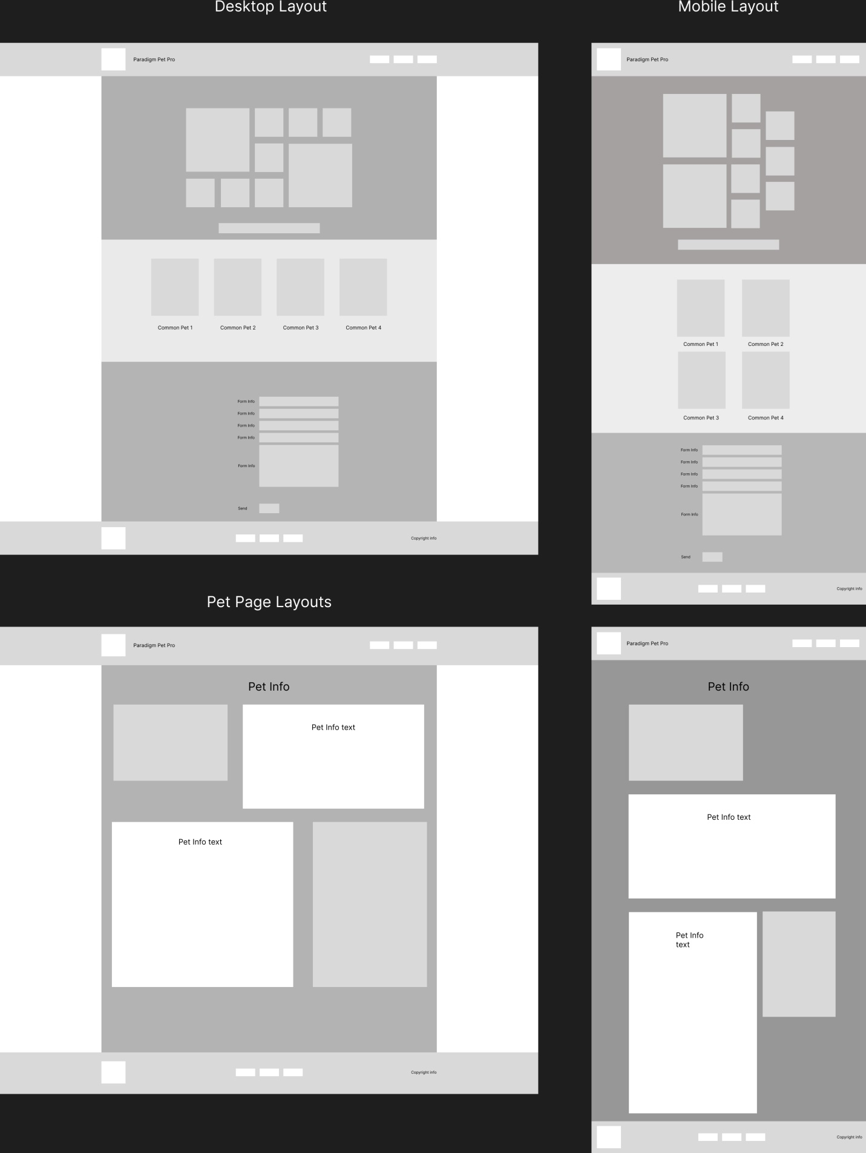

A5:

The layout proposed provides the user with an easy way to select and see information about their chosen pet or future pet. For the stakeholders they have potential customers through voluntary email mailing list signups through the contact form, as well as links to their products that are relevant for the animal or pet selected by the user. These links can be imbedded within the information about pet care and or health related information. Need to know what Ick looks like on fish and how to treat it? There will be a link to some stakeholder products that can assist with that as well as information for the user about the issue. Although the wireframe above does not lay out every little spot where links would be, all that will be added in the prototype page upon stakeholders request.

A6:

Primary navigation elements would be within the header Nav bar section as well as the footer of the site on all related pages. This is the most common website layout that users would be accustom to. The secondary navigation links would be in the Most Common Pets section just under the Hero section of the home page, by clicking on the pet image the user would be taken to that animal’s related page. As for the stakeholders, links and images of the products being sold could be added in the Hero section of the page where clicking on the image could take you to that companies web page for further sales. By having normalized navigation methods that more users are use to, links for stakeholder products could be placed to maximize potential clicks to their sites. Users get the information they are looking for in an easy manner, and companies get eyes on their products.

B:

